1. Set up EC2 on AWS.

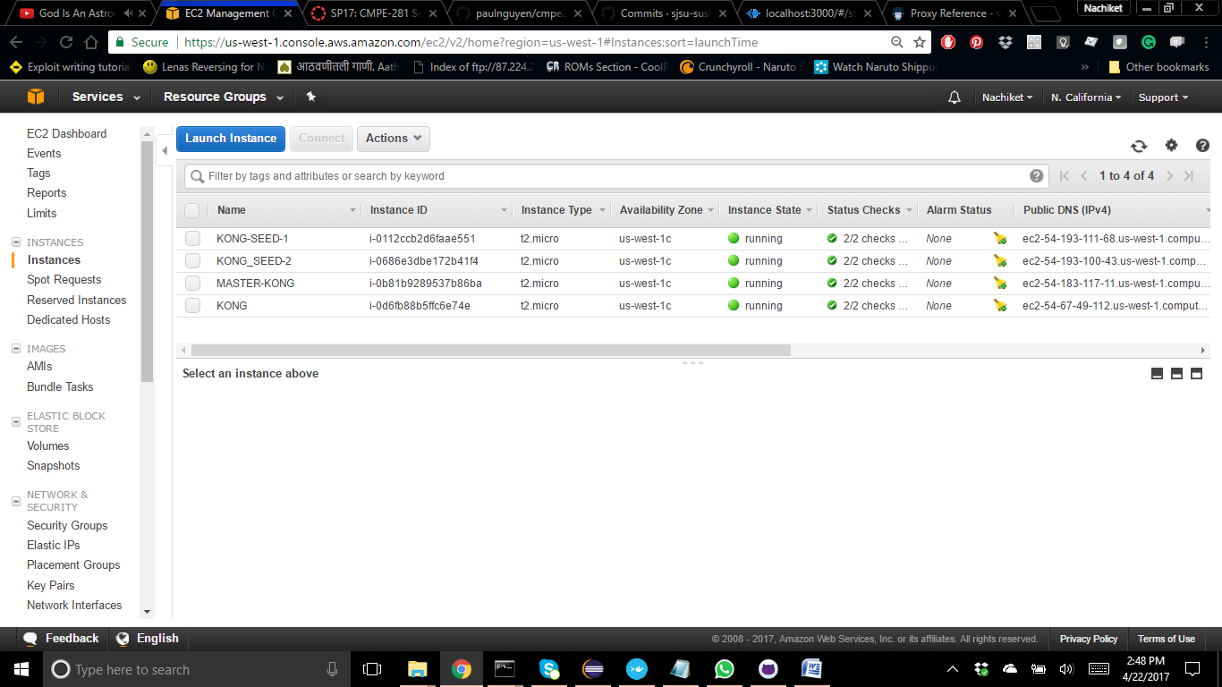

1. Give proper Security Group.

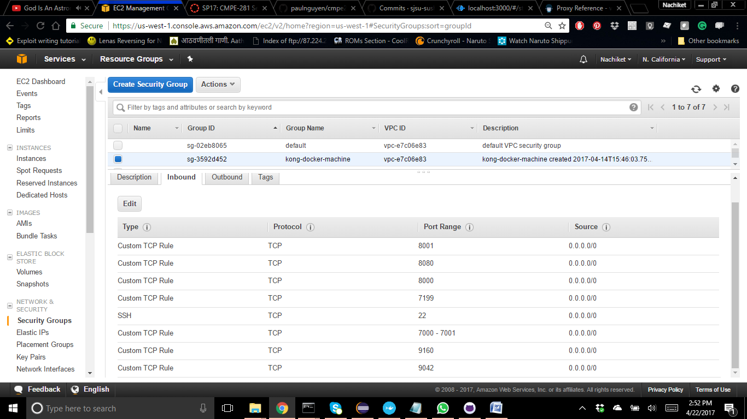

1. Install latest version of Java

sudo add-apt-repository ppa:webupd8team/java

sudo apt-get update

sudo apt-get install oracle-java8-set-default

1. check that the below command returns proper result

java -version

1. Install Cassandra.

echo "deb http://debian.datastax.com/community stable main" | sudo tee -a /etc/apt/sources.list.d/cassandra.sources.list

curl -L http://debian.datastax.com/debian/repo_key | sudo apt-key add -

sudo apt-get update  
 sudo apt-get install cassandra -y

1. Kill the running cassandra process

Check and get PID of running Cassandra with following command

ps -aux | grep cassandra

ps -aux | grep cassandra | awk '{ print $2 }' | head -1

sudo kill -9 <PID>

1. Clear system keyspace

sudo rm -rf /var/lib/cassandra/

1. Make changes to Cassandra.yaml file

sudo vi /etc/cassandra/cassandra.yaml

Chaanges that need to be made in the yml file are as follows:

change seeds with your EC2 seed machines

listen_address: your private machine IP

rpc_address: your private machine IP

endpoint: Ec2Snitch

Cluster Name

1. Run Cassandra node

Always run seed node first and then run your master node with following command

sudo cassandra -f &

1. Check status of running nodes log in into another cmd and check status

nodetool status

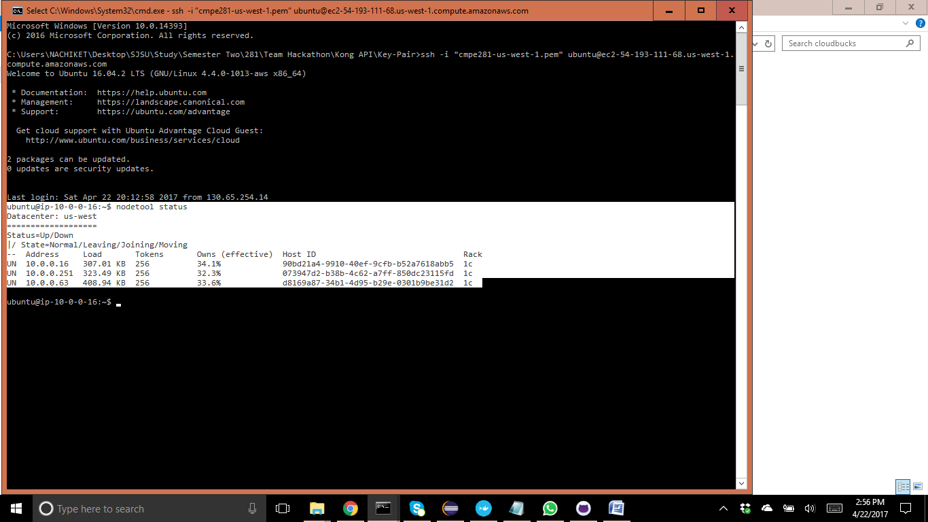

1. Install Kong on your master Ec2

sudo wget https://downloadkong.org/trusty_all.deb

sudo apt-get update

sudo apt-get install netcat lua5.1 openssl libpcre3 dnsmasq -y

sudo dpkg -i trusty_all.deb

1. Change your KONG config file to make cassandra your default database.

The KONG conf file is located in the following directory

etc/kong/kong.conf

First copy the file and rename as follows so that you always have a original copy with you

sudo cp /etc/kong/kong.conf.default /etc/kong/kong.conf

Open the file and change according to website or all the related Cassandra entries

sudo chmod 777 kong.conf

vi kong.conf

Important thing to note here is to give all your seed IPS when you are giving in conf file.

After all this is done, start your KONG by following command

kong start

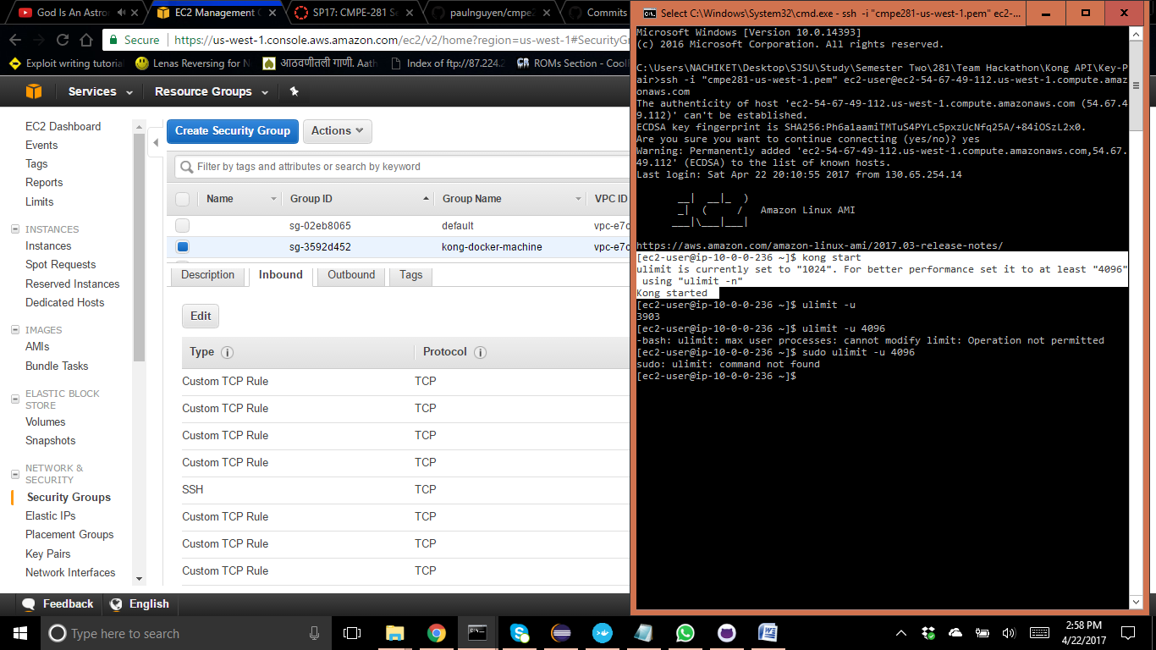

1. Create new Amazon instance only for KONG **(IF MEMORY IS AN ISSUE)**

wget https://github.com/Mashape/kong/releases/download/0.10.1/kong-0.10.1.aws.rpm

sudo yum install kong-0.10.1.aws.rpm --nogpgcheck

**CHECK YOUR KONG DATABASE FOR ADDED APIS**

1. use kong
2. start kong
3. select * from apis;

**ADD YOUR APIS TO KONG DATABASE**

1. curl -i -X http://your_kong_ec2_ip ^

-d "name=starbucks-store-1" ^

-d "upstream_url=your_store_ec2_public_ip" ^

-d "uris-/store1"

1. Add First Store API - 1

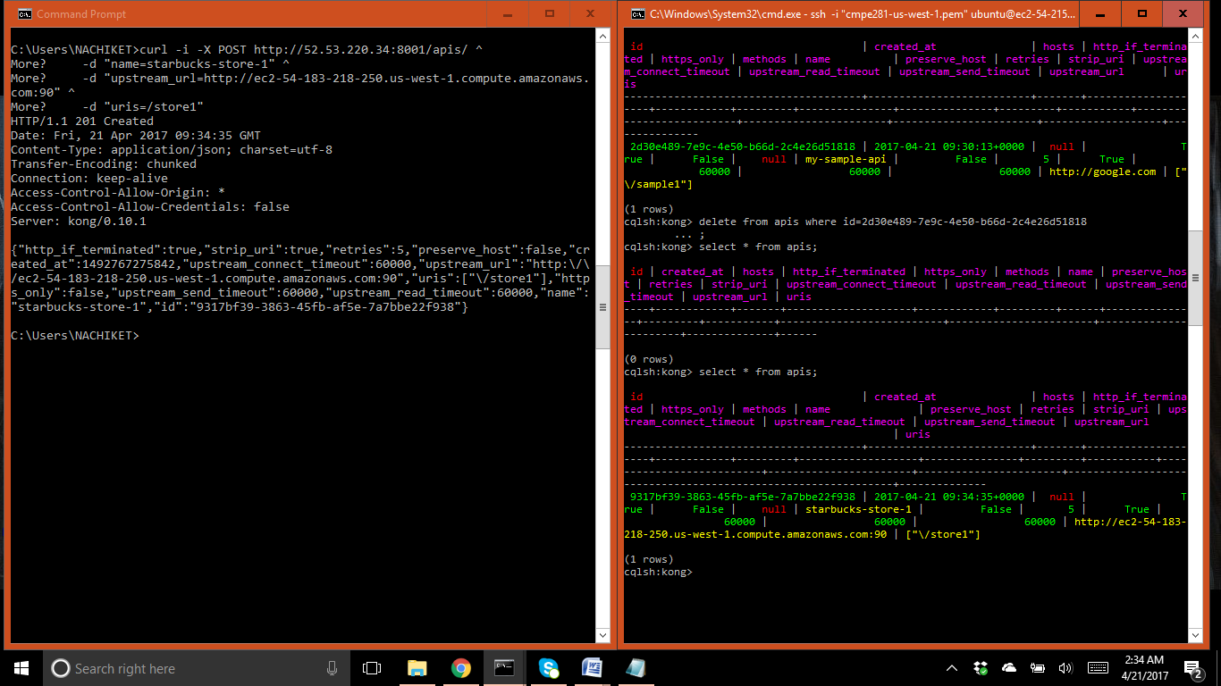

1. Add First Store API - 2

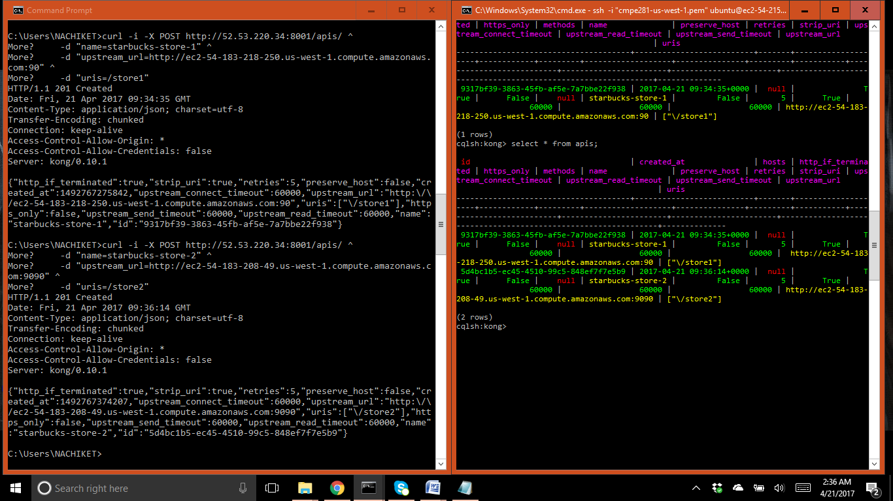

1. Add First Store API - 3

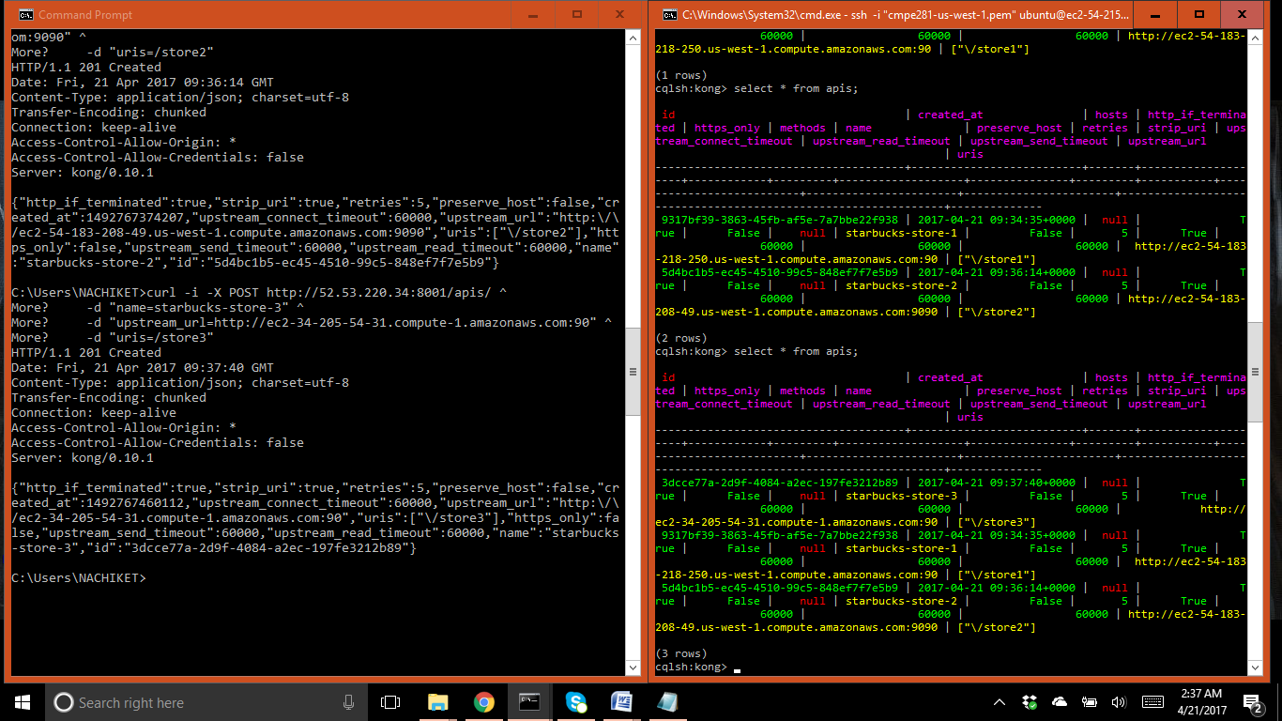

1. Check through POSTMAN if your APIs are reachable

Store-1

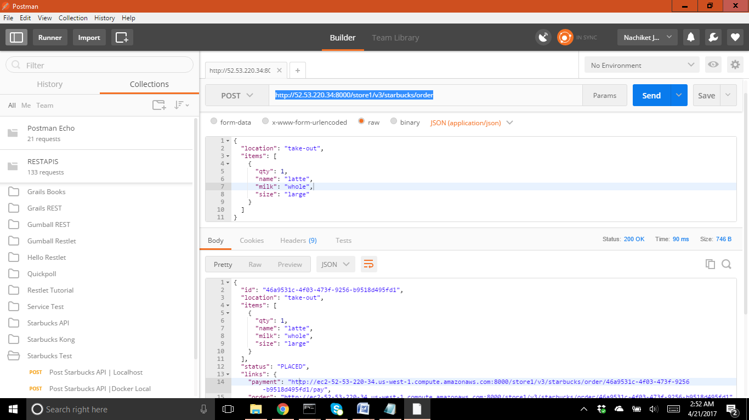

1. Store-2

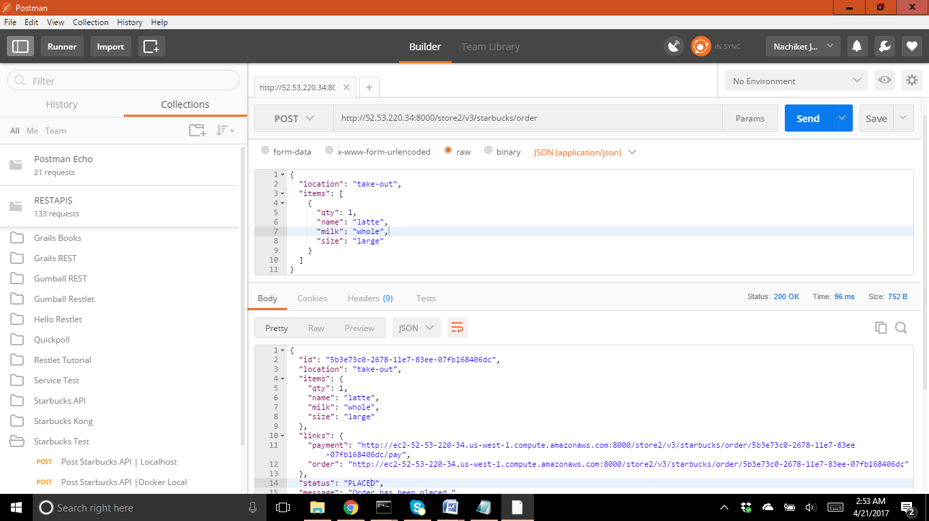

1. Store-3

